Assignment-2

You had designed a dashboard and story points previously. Now, it is time to integrate Python and incorporate the output(s) in it. The ultimate goal in this assignment is to finalize the dashboard and story points for users who want to learn more about the airbnb data about your chosen city before traveling somewhere.

1. **Where we left**

**Open** your designed Tableau workbook for the previous assignment and **tweak** the dashboard and story point design.

A user will be able to find your product (the dashboard and story points slides) is friendly and useful when making travel arrangements.

1. **Integrate Python Code Chunk**

**Integrate** any Python code in a new worksheet in a visualization and show its calculated output(s) in the dashboard meaningfully in the context and story points in any way.

You are very flexible to choose the code. Feel free to use any advanced code or any simple code (really!) as in my tutorial video. Make sure the integration will give insights or support the visualization in the context for users.

1. **Save and Pack**

The packaged Tableau workbook has the extension of **.twbx (not the other extension)**. This keeps the dataset. Save the workbook in .twbx. Give it a filename of {your_first_name}_{city_name}.twbx. Then export your own copy as a packaged workbook. Since it is a packaged workbook you will not need the data to attach with it. You won’t submit this packed workbook. Just keep for own copy. You will publish on the Tableau server.

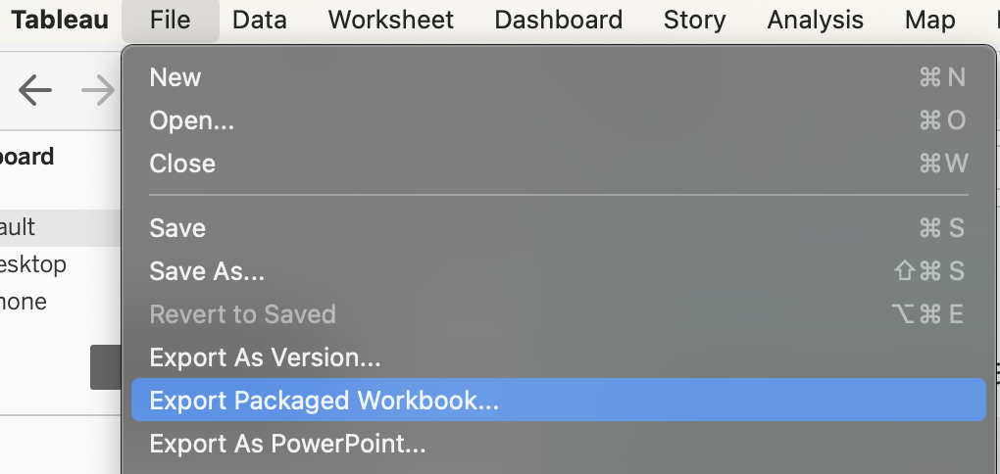

1. **Publish**

Publish your work on the Tableau Online server or its web. Remember you have 2-weeks access so this is the time interval the instructor will check the link before it expires. You will need to create an online account on Tableau Online/Server. Expect some issues.

Just check the link you have published the Tableau Online web link of your dashboard along with story points that can be shared with any one.

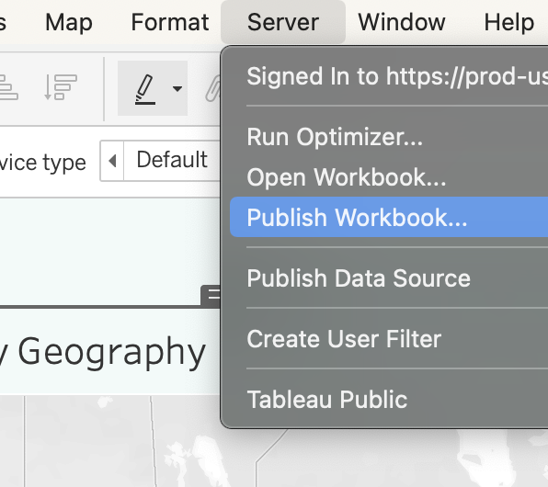

1. **Submit**

**Submission details** on myCourses**. 1) Submit** the published workbook web link, 2) **Submit** two nice screenshots of your work (showing the best parts), **3) Include** team members (actually, only one submission per team through myCourses once i set up teaming-up), and  **4)** **Keep** a copy of the packaged workbook file, named i.twbx, on your own drive so you can use it for the future..

Worst case scenario: In case of Online/Server issues (expiration or script issue), it is ok to submit only the packed file, instead of the accessible link. The instructor will spend time downloading and opening it. (Again, this is a really exceptional case, try to avoid it or use alternative ways!)

Also there is nothing to post under Discussions.

1. **Evaluation**

Your dashboard design will be evaluated based on the practices in the hands-on video instructions and the integration instruction.

**Collaborative work is welcomed!** Teams can work together on this assignment (Tableau server/online allows collaboration features on the web though). Just include team members in the comments when submitting.

**Troubleshooting:**

* <https://www.tableau.com/about/blog/2021/2/tableau-online-analytics-extensions-now-available>